1. 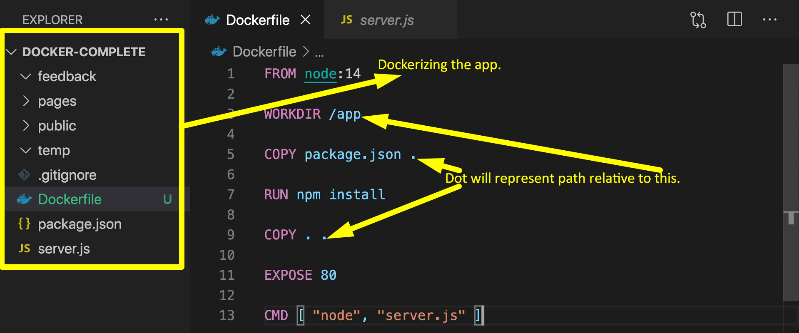
2. 
3. 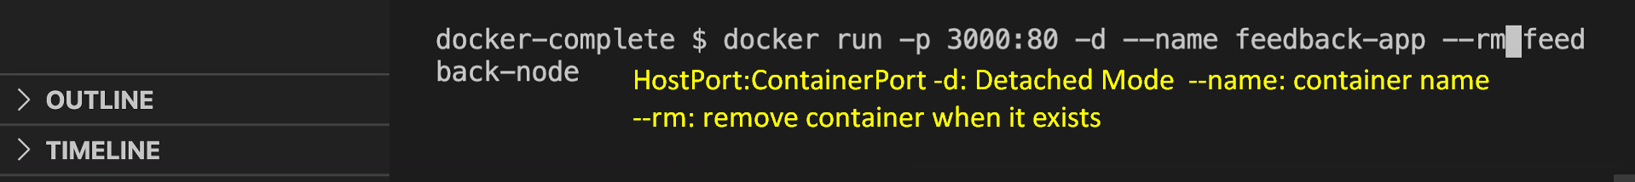
4. Jatin: Nothing special. Just app was run. A file was generated when a user enters form data and that file is stored as txt file in temp folder and feedback folder and then that file was shown in the browser when we hit a dedicated endpoint with file name (note: File name is as that of the title’s value we enter when storing a file), the file’s content is shown.  
   Then the mentor shows that the file is not stored on the host machine but inside the container as we’re accessing the web app from the container via the host but everything is being stored inside the container. That is all.  
   